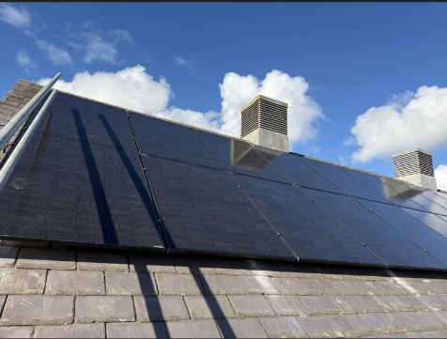
Northumberland Community Energy Limited (NCEL)
The Solar-Powered Building Project is working to enable community buildings reduce their energy bills, reduce their carbon footprint and boost their long-term resilience to the impacts of climate change and fluctuating energy markets.
NCEL project manages the installation, maintenance and all risks of the system over the 20-year partnership.
Newton & Bywell

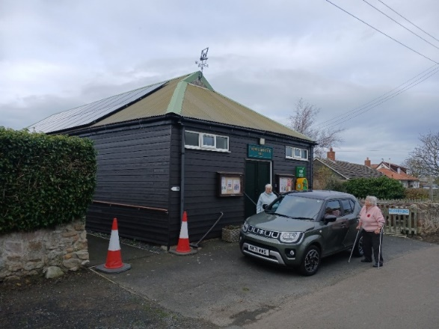
The main steps along the way:
Following a hall/centre/church’s interest to join the project, an initial feasibility study is carried out by a recognised contractor on behalf of NCEL.
Once funds are in place to proceed, the next stage is securing planning permission for the siting of panels and batteries.
A Lease is agreed between NCEL and the community building with respect to the siting of NCEL panels and batteries and includes a power purchase agreement where the community building purchases the solar electricity consumed by the building at a fixed price of £0.15 per kWh for the term of the lease. The lease will be drawn up by solicitors, independently acting for both parties, engaged and funded by NCEL. A solar PV contractor will be procured and once the lease is in place we can agree an installation date. This process can take up to 2 months.
All capital and revenue costs associated with installing panels and batteries are covered by NCEL.
There is an accompanying How it Works summary sheet and information on the Community Action Northumberland website Solar-Powered Community Buildings
Beadnell

NCEL was formed in 2023 as a not-for-profit Community Benefit Society. It is supported by representatives from community buildings and the founding partnerships of Community Action Northumberland (CAN), Rural Design Centre (RDC) and National Innovation Centre for Rural Enterprise (NICRE). NCEL is regulated by the Financial Conduct Authority and works for the best interest of the community.
Progress of Community Buildings
To date we have installed solar PV and battery systems at 11 buildings.
- Corsenside – installed 28th August
- Longhoughton – installed 6th September
- Beadnell – installed 19th October 2024
- Barrasford – installed 23rd October 2024
- Whitley Chapel – installed 12th November 2024
Whitley Chapel Parish Hall
- Creighton Memorial Hall – installed 4th December 2024
- Humshaugh Village HALL – installed 20th December 2025
- Thropton Village Hall - installed 14th January 2025
- Newton & Bywell – installed 28th February 2025
- Crookham Village Hall – installed 12th May 2025
- Felton Village Hall – installed 23rd May 2025

Once NCEL have secured funds we hope to install up to 8 or more buildings from the list below during 2025.

- Lesbury Village Hall
- Cheviot Centre
- Stannington
- St Pauls Church, North Sunderland
- Seahouses Hostel
- Allendale Village Hall
- Tarset Village Hall
- Mathew Ridley Memorial Hall, Falstone
- Carrshield Village hall
- Mitford Village Hall

There are 18 buildings with a feasibility study and planning approval awaiting the next steps.
Currently we have 58 buildings who have a completed solar installation feasibility study or awaiting their visit and report.
In the last few months 8 community buildings have expressed an interest to join the project
In total we are working with 95 buildings who are at various stages in the project.

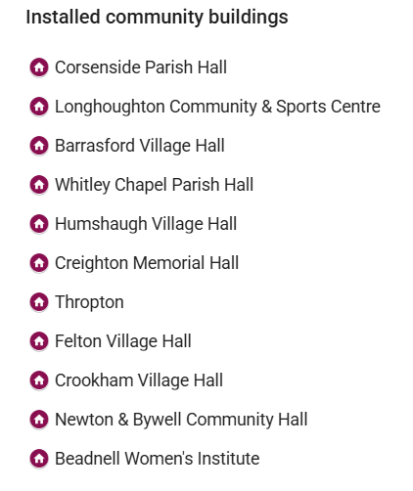
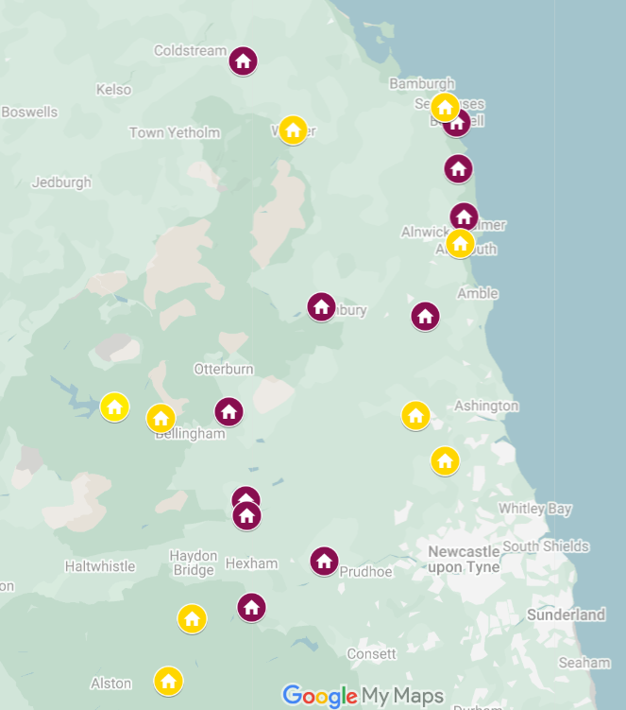
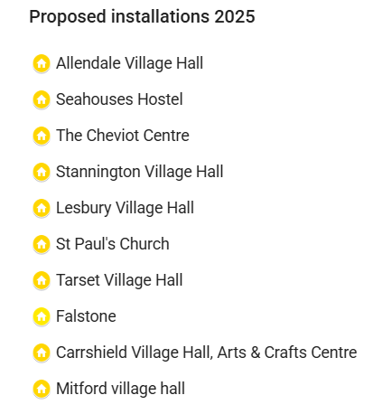

Communication and Sharing
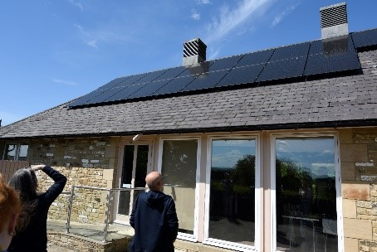
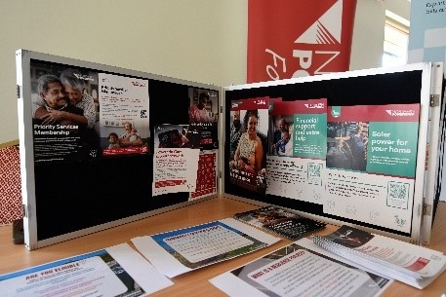
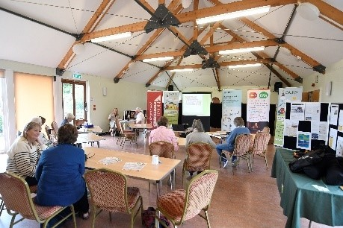
NCEL and CAN Energy Roadshow at Newton & Bywell Village Hall on Tuesday 6th May 2025.
We reached halls in the southern part of the County with the opportunity to learn more about NCEL, the Solar-Powered Building process, update on progress and view the installation at Newton & Bywell. Representatives from CAN’s CAIRN project outlined the impartial, energy advice available to homeowners and energy audits available for Village Halls through Jake Delacy, Community Building’s Energy Adviser. Northern Power Grid Foundation were available to discuss funding. 30 people attended the event.

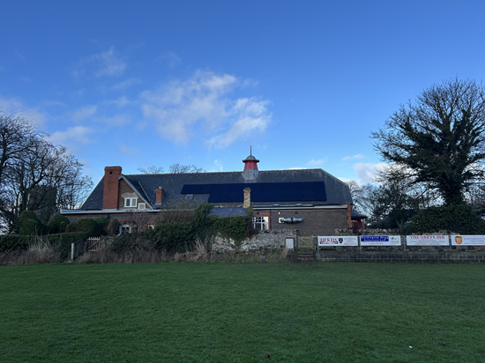
NCEL’s held its first AGM was on Tuesday 18th March 1pm – 4pm kindly hosted by Creighton Memorial Hall, Embleton. It was well attended by members and the public. Minutes are available by request.
There was a great turnout of members and non-members for the first Northumberland Community Energy Limited (NCEL) AGM last week.
It was kindly hosted by the trustees of Creighton Memorial Hall, Embleton, which is one of 9 sites where NCEL have installed solar PV panels and battery systems for the benefit of the Hall community. Following the AGM business, there were two main presentations:
- Jess Cook, Head of Northern Powergrid Foundation explained why the Foundation exists and the expansion of its offer – including the Foundation’s Resilience Grants. The window for applications has now closed but there will be another opportunity later in the year.
- Paul Cowie, CEO of Rural Design Centre and NCEL Company Secretary introduced the ‘North East Carbon & Nature Market Place', a platform to catalyse investment into biodiversity and decarbonising projects by the private sector.
Christine Nicholls from CAN introduced our new Community Buildings Energy Advisor Jake Delacey and CAN’s offer of free energy audits (for more information: jakedelacey@ca-north.org.uk).
Shelagh Coxon of Creighton Memorial Hall talked about the successful partnership with NCEL, the installation of panels and batteries at the Hall and the benefits already being felt.

Keep your eyes out for articles in CAN newsletter News | Community Action Northumberland and CAN Facebook (6) Facebook

Funding
Energy Savings Trust - Energy Redress fund
NCEL and CAN successfully applied to the Energy Savings Trust - Energy Redress fund.
We have funding from March 2025 – March 2027 for:
21 planning applications
31 legal agreements
13 roof surveys
Rural Design Centre have funding for a Graduate Innovation Associate who will support some of the work of NCEL.
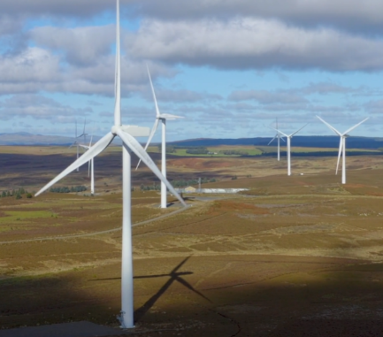
Wind Farm Community Funding
A number of community buildings engaged with the Solar-Powered building project lie within the catchment area of several wind farms that offer funding for local projects. In 2025 NCEL will explore how this funding could support solar PV panels and battery installation. Use the link below to check your eligibility for funding.
Wingates Wind Farm Community Grants Scheme | Empowering Organisations | Community Action Northumberland

RAMP 2025
NCEL will be applying for RAMP funding to deliver up to 8 installations at a cost of up to £150,000 from July – December 2025. Application to be submitted early May with a hopeful decision in June.

Borderlands Energy Investment Programme
NCEL has submitted an application to Borderlands for funding for capital funding to install solar PV and battery systems in community buildings, who are part of NCEL’s Solar-Building Programme from 2026 – 2028. We hope to hear if we are successful at the end of summer 2025.
NCEL billing
The second round of invoices were issued for January – March 2025. The income from 8 Halls was £1,050

Northern Power Grid Foundation
The Northern Power Grid Foundation offers grants to communities to strengthen community resilience and promote greener energy. NCEL are working with communities who have received NPGF funding and wish to join NCEL to install solar power and battery systems. Their community building and benefit from the ongoing monitoring, maintenance, repair and renewal offered by NCEL through the Solar-Powered Buildings project. Consider applying to NPGF for funding to support your buildings resilience and move to greener energy.
Homepage | Northern Powergrid Foundation

Operational
Battery Safety
NCEL is aware of the risks posed by Li-Ion batteries stored in community buildings. We are working with NICRE and Tyne & Wear Fire Service to develop guidance for community buildings. The first-round table discussion of interested partners took place on 13th May at The Catalyst, Newcastle. Representatives from NCEL, CAN, NICRE, Northumberland Fire Service and Community Buildings were present. A full report from the meeting and first draft of local guidelines will be produced in due course. As a first action Scott Ruddick, Fire Safety Inspector for Northumberland Fire and Rescue Service will visit all 11 installations with Fiona Knox in the early part of June to review systems and make recommendations.

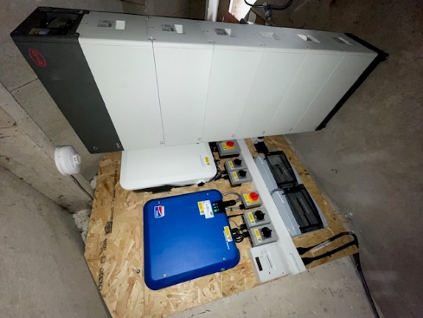
Battery Optimisation.
NCEL is working with a local company, Smart Origin, to develop a battery optimisation model to further improve this process. On the back of a desire to optimise systems we have installed an initial extra 2.76 kWh battery capacity at Thropton Memorial Village Hall with prospect of increasing this further. We are installing and additional 16.56 kWh battery storage at Whitley Chapel with capital underspend from last round of RAMP funding.
Barrasford
We have also purchased £372 of smoke and heat detectors that will be installed with future installations.

Smart Export Guarantee (SEG)
For any solar electricity that is exported, NCEL is responsible for securing the SEG with the mains electricity supplier for that building. For each building, NCEL enters into a G98 or G99 agreement with Northern Power Grid or Scottish Power depending on the anticipated degree of export. We also need the building to have a smart meter in place or retro fitted so the amount exported can be agreed with the mains supplier. We are currently recording where smart meters are in place and operational. We have registered an account for NCEL as a generator of Renewable Energy Guarantees of Origin (REGO) with Ofgem.
We met with Jon Kent of Zecoenergy and Smart Grid Controls to discuss an option of them handling all export accounts on behalf of NCEL and explored peer to peer trading in the future. We have had discussion with Younity and may go back to them.

Energy Generation and Carbon Saved
As of 20th May 2025 – midday, across all community buildings
Solar Energy Generated kWh | Consumed Solar Energy kWh | CO₂ Avoided  tonnes
45,244 | 17,540 | 31.10

